|  |  |
| --- | --- |
| Proposer Information | |
| **Bidder (Company) Name:** | **Formerly:** |
| Mailing Address: | Street Address: |
| City, State, Zip: | City, State, Zip: |
| Type of Entity: *(check one)*  Corporation Partnership Proprietorship Joint Venture | |
| Contact Person: | Title: |
| Email Address: | Website Address:  www. |
| Telephone Number: | Toll Free Phone Number: |
| Fax Number: | Cell Phone Number: |
| Federal Employer Identification Number (FEIN): | SSN (if Sole-Proprietorship or Partnership):    *Only required if FEIN is not provided* |
| Incorporated in the State of: Year: | |
| General Contractor License #: | |
| Available Bonding Capacity: $ Aggregate: $ Single Project Limit: $ | |
| Surety Company: A.M. Best Rating: | |
| This form must be completed and returned with your Proposal to fulfill the requirements of Page 15, Section 1b | |

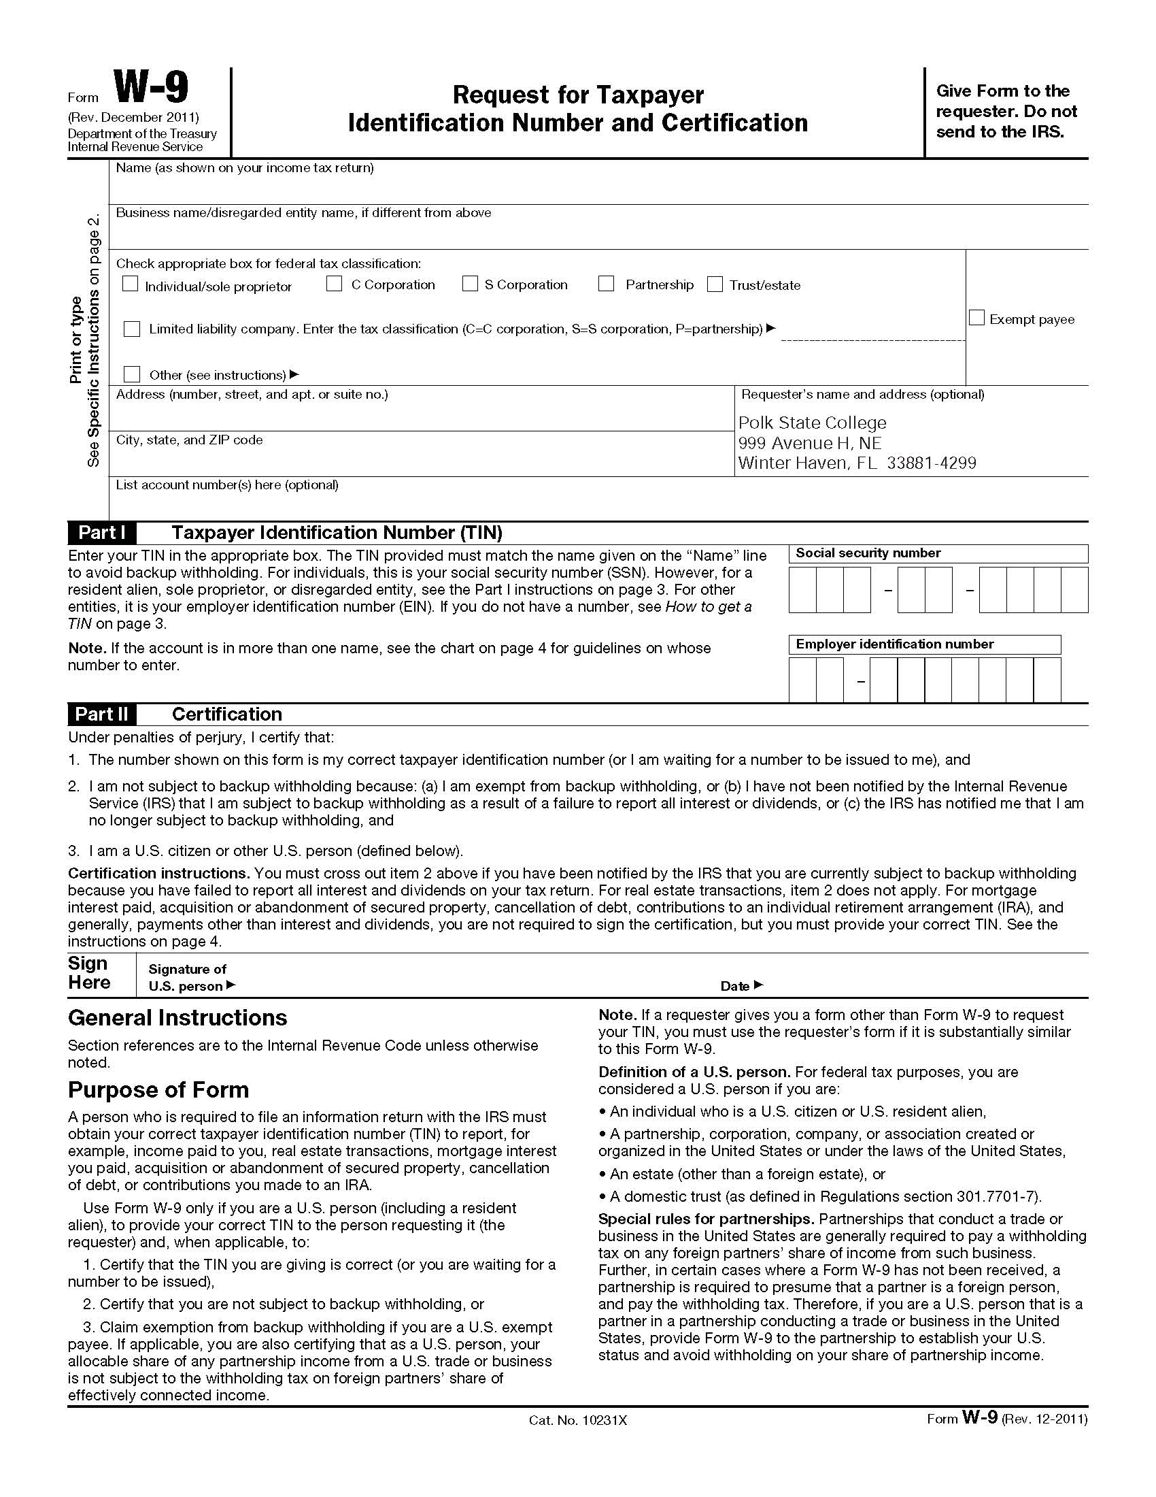

|  |
| --- |
| DRUG-FREE WORK PLACE FORM |
| The undersigned vendor in accordance with Florida Statute 287.087 hereby certifies that _________________________________________ does:  *(Name of Business)*  1. Publish a statement notifying employees that the unlawful manufacture, distribution, dispensing, possession, or use of a controlled substance is prohibited in the workplace and specifying the actions that will be taken against employees for violations of such prohibition.  2. Inform employees about the dangers of drug abuse in the workplace, the business's policy of maintaining a drug-free workplace, any available drug counseling, rehabilitation, and employee assistance programs, and the penalties that may be imposed upon employees for drug abuse violations.  3. Give each employee engaged in providing the commodities or contractual services that are proposed a copy of the statement specified in subsection (1).  4. In the statement specified in subsection (1), notify the employees that, as a condition of working on the commodities or contractual services that are under bid, the employee will abide by the terms of the statement and will notify the employer of any conviction of, or plea of guilty or nolo contendere to, any violation of Chapter 893 or of any controlled substance law of the United States or any state, for a violation occurring in the workplace no later than five (5) days after such conviction.  5. Impose a sanction on, or require the satisfactory participation in a drug abuse assistance or rehabilitation program if such is available in the employee's community, by any employee who is so convicted.  6. Make a good faith effort to continue to maintain a drug-free workplace through implementation of this section.  As the person authorized to sign the statement, I certify that this firm complies fully with the above requirements.  **🗶**   |  |  | | --- | --- | |  | Submitting Firm's Signature | |  | Date | |
| Use this form regarding Page 16, Section 1e  ***This form (if applicable) must be completed and returned with your Proposal*** |

|  |  |
| --- | --- |
| Disputes Disclosure  Summary of Litigation | |
| **Answer the following questions by placing an "🗶" or check “✓” in the box (🗷or ☑) after "YES" or "NO". If you answer "YES", please explain via attachment.**  Disclosure can be limited to the regional/district office which will be supporting this Contract. | |
| **YES**  **NO** | Has your firm, or any of its officers, received a reprimand of any nature or been suspended by the Department of Professional Regulation or any other regulatory agency or professional association within the last five (5) years? |
| **YES**  **NO** | Has your firm, or any member of your firm, been declared in default, terminated or removed from a contract or job related to the services your firm provides in the regular course of business within the last five (5) years?  If yes, indicate company name, contact name and telephone number, length of service provided, and reason for early cancellation/termination of contract. |
| **YES**   **NO** | Has your firm had filed against it or filed any requests for equitable adjustment, contract claims or litigation in the past five (5) years that is related to the services your firm provides in the regular course of business?  If yes, state the nature of the request for equitable adjustment, contract claim or litigation, a brief description of the case, the outcome or status of suit and the monetary amounts involved. |
| By submission of this form, Proposer certifies that all statements made are true, and agree and understand that any misstatement or misrepresentation or falsification of facts shall be cause for forfeiture of rights for further consideration of this procurement. | |
| ***Complete & include this form with your Proposal to fulfill the requirements of Page 20, Section 9*** | |

|  |
| --- |
| Schedule and Budget Compliance  Synopsis of Projects Completed in the Last 5 Years |

|  |  |  |  |  |
| --- | --- | --- | --- | --- |
| **Project Name** | **\*Schedule Compliance** | **Project Budget** | **Final Cost** | **Under or Over $** |
|  |  | $ | $ | $ |
|  |  | $ | $ | $ |
|  |  | $ | $ | $ |
|  |  | $ | $ | $ |
|  |  | $ | $ | $ |
|  |  | $ | $ | $ |
|  |  | $ | $ | $ |
|  |  | $ | $ | $ |
|  |  | $ | $ | $ |
|  |  | $ | $ | $ |
|  |  | $ | $ | $ |
|  |  | $ | $ | $ |
|  |  | $ | $ | $ |
|  |  | $ | $ | $ |
|  |  | $ | $ | $ |
|  |  | $ | $ | $ |

* In this column, indicate either:

1 = Completed ahead of schedule

2 = Completed on schedule

3 = Late Completion

***This form (or an alternate form as determined by the Proposer – ensure all requested information is included) must be completed and included with your Proposal to fulfill the requirements of Page 18, Section 4a.***

|  |  |
| --- | --- |
| Current or Completed Projects | |
| Current Project /Scheduled Completion Date: ___________  Completed on _____________  Experience of the **Proposer** or  Experience of **Individual**: _____________________  While working at *(individual’s former employer)* | |
| Project Name:  Type of Project: | **Insert Photo** |
| Project Scope or Summary of Work: | |
| Client: | |
| Address: City, State, Zip: | |
| Contact Person: EMail: | |
| Phone: ( ) Fax: ( ) | |
| Project Budget *(building & site):* Original*:* $ _______________ Current/Final: $ _______________ Over/Under Budget: $______________ | |
| Explain differences in contract original/final amounts:  Management techniques used to prevent budget overages: | |
| Original Project Completion Date: Revised to: Actual Completion Date:  Explain Differences: | |
| Project Manager: | |
| Attach a list/schedule of all members of the project team for this referenced project who will also be assigned to this contract, and their roles.  ***This form* *will fulfill the requirements of Page 18, Section 6.***  ***Include in Section 6 of your Proposal*** | |

|  |
| --- |
| Project Photos |
| **Insert “Before” Photo or Schematic Design of Project** |
| **Final photo of completed project (from same viewpoint of above, if possible)** |
| ***This form* *will fulfill the requirements of Page 18, Section 6***  ***Include in Section 6 of your Proposal*** |

|  |
| --- |
| Project Manager |
| **Project Manager’s name:** |
| Include up to five (5) similar projects in which the proposed Project Manager/Superintendent has served  in the capacity of Project Manager during the past ten (10) years. |
| **Project Name:** |
| **Company/Owner: Completion Date:** |
| **Address:** |
| **Contact Person:** |
| **Phone Number: EMail:** |
| **Summary of Work:** |
| **Project Name:** |
| **Company/Owner: Completion Date:** |
| **Address:** |
| **Contact Person:** |
| **Phone Number: EMail:** |
| **Summary of Work:** |
| **Project Name:** |
| **Company/Owner: Completion Date:** |
| **Address:** |
| **Contact Person:** |
| **Phone Number: EMail:** |
| **Summary of Work:** |
| **Project Name:** |
| **Company/Owner: Completion Date:** |
| **Address:** |
| **Contact Person:** |
| **Phone Number: EMail:** |
| **Summary of Work:** |
|  |

***This must be completed and included with your Proposal to fulfill the requirements of Page 19, Section 7d.***

|  |
| --- |
| Project Superintendent |
| **Project Superintendent’s name:** |
| Include up to five (5) similar projects in which the proposed Superintendent has served  in the capacity of Project Superintendent during the past ten (10) years. |
| **Project Name:** |
| **Company/Owner: Completion Date:** |
| **Address:** |
| **Contact Person:** |
| **Phone Number: EMail:** |
| **Summary of Work:** |
| **Project Name:** |
| **Company/Owner: Completion Date:** |
| **Address:** |
| **Contact Person:** |
| **Phone Number: EMail:** |
| **Summary of Work:** |
| **Project Name:** |
| **Company/Owner: Completion Date:** |
| **Address:** |
| **Contact Person:** |
| **Phone Number: EMail:** |
| **Summary of Work:** |
| **Project Name:** |
| **Company/Owner: Completion Date:** |
| **Address:** |
| **Contact Person:** |
| **Phone Number: EMail:** |
| **Summary of Work:** |
|  |

***This must be completed and included with your Proposal to fulfill the requirements of Page 19, Section 7e.***

|  |  |  |  |
| --- | --- | --- | --- |
| **Bidder:** | | | |
| References | | | |
| Educational  Client Name / Address | Contact Person | Telephone &  Fax Number | |
|  | Name:  **EMail**: | Phone: |  |
|  | Toll Free: |  |
|  | Fax: |  |
|  | Name:  **EMail**: | Phone: |  |
|  | Toll Free: |  |
|  | Fax: |  |
|  | Name:  **EMail**: | Phone: |  |
|  | Toll Free: |  |
|  | Fax: |  |
|  | Name:  **EMail**: | Phone: |  |
|  | Toll Free: |  |
|  | Fax: |  |
|  | Name:  **EMail**: | Phone: |  |
|  | Toll Free: |  |
|  | Fax: |  |
| Non-Educational  Client Name / Address | Contact Person | Telephone &  Fax Number | |
|  | Name:  **EMail**: | Phone: |  |
|  | Toll Free: |  |
|  | Fax: |  |
|  | Name:  **EMail**: | Phone: |  |
|  | Toll Free: |  |
|  | Fax: |  |
|  | Name:  **EMail**: | Phone: |  |
|  | Toll Free: |  |
|  | Fax: |  |
|  | Name:  **EMail**: | Phone: |  |
|  | Toll Free: |  |
|  | Fax: |  |
|  | Name:  **EMail**: | Phone: |  |
|  | Toll Free: |  |
|  | Fax: |  |
| Include Email Address  *This form must be completed and included with your Proposal to fulfill the requirements of* ***Page 21, Section 11a****.* | | | |

**Be sure to reconfirm all EMail addresses prior to submittal to ensure they are up-to-date.**

|  |  |  |  |
| --- | --- | --- | --- |
| Minority / Woman Owned Business Statement | | | |
| Type of Business: *Check applicable block(s)*  ❑ **“African-American”** includes persons having origins in any of the black racial groups of Africa.  ❑ **“Hispanic American”** includes persons of Mexican, Puerto Rican, Cuban, Central or South American, or other Spanish cultures or origins, regardless of race.  ❑ **“Native American”** includes American Indians, Eskimos, Alaskan Indians, Aleuts and Native Hawaiians.  ❑ **“Asian-Pacific Americans”** includes persons whose origins are from Japan, China, Taiwan, Korea, Southeast Asia, the Philippines, Samoa, Guam, the U.S. Trust Territories of the Pacific, and Northern Marianas.  ❑ **“Asian-Indian Americans”** includes persons whose origins are from India, the Indian Sub-Continent and Pakistan.  ❑ **“Woman-Owned Business Enterprise”** | | | |
| **Note:** MBE and WBE are defined by Federal Register 49 CFR, Part 23, as a business firm which as at least fifty-one percent (51%) owned by minority or women group members, or in the case of a publicly owned business, at least fifty-one percent (51%) of the stock of which is owned by the minority or woman. The minority or woman ownership must exercise actual day-to-day management and control of the business. | | | |
| Company Name: | | | |
| Certified by (*name of Public Entity, if applicable*) | | | |
| Certificate Number:  Attach a copy, please. | | | |
| Polk State is required to report M/WBE expenditures to the State of Florida’s Office of Supplier Diversity (OSD) on an annual basis. The report includes a supplemental list of firms who have indicated that they are owned by a woman or minority, but have not been certified by OSD, although they may be certified by other public entities.  It is requested that M/WBE owned firms complete this page and include it with their Proposal in section 1  **For reporting purposes only** | | | |
| Statement of No Proposal  RFQ #15-04 | | | | |
| If your company does not intend to propose on this procurement, please complete and return this form prior to the date shown for receipt of proposals via fax to 863-297-1085, or via EMail to [purchasing@polk.edu](mailto:purchasing@polk.edu), or mail to:  Polk State College  Purchasing Department  999 Avenue H, Northeast  Winter Haven, Florida 33881-4299  We, the undersigned, have declined to propose on the above referenced RFQ for the following reason(s):  Scope of Work or Terms & Conditions are too "restrictive." (*please explain below*)  Unable to meet requirements (*please explain below*)  RFQ was unclear (*please explain below*)  Insufficient time to respond  We do not offer this type of service or equivalent  Our employee manloading would not permit us to perform  Unable to meet bond or insurance requirements  Other (*please explain below in “Remarks”*) | | | | |
| Remarks: | | | | |
|  | | | | |
| **Remove us from your “Vendor Database”** | | | | |
| Company: |  | Date: |  | |
| Signature: |  | Printed Name: |  | |
| Failure to submit either a Proposal or a *Statement of No Proposal Submittal* shall be cause for removal from the vendor database.  Use this form regarding Page 5, Section 7. | | | | |
| |  | | --- | | Checklist | | | | | | |
| This checklist is provided to assist each Proposer in the preparation of their Proposal. Included in this check list are important requirements which are the responsibility of each Proposer to submit with their response in order to make their Proposal fully compliant. This checklist in only a guideline – it is the responsibility of each Proposer to read and comply with the RFQ in its entirety. | | | | | |
| **Check (✓) each of the following when accomplished:**   * Outside of box is marked accordingly: **RFQ #15-04, CM@Risk - WLR 3rd Floor Remodel/Renovation, Due Date: June 17, 2015.** If you hand-deliver the Submittal, use the form provided on the website. * **Two (2)** electronic copies are included. Place in an envelope and place in the box. * The **eight (8)** binders do not need to be placed in separate envelopes within the box.Box is sealed with tape. * Is the final Addendum (if issued) signed and included? * Is *Proposer Information Form* (**page 32**) complete and included in Section 1? * Is *Drug-Free Workplace* form (**page 34**) signed and enclosed in Section 1, if applicable? * Is the *Disputes Disclosure* form (**page 35**) completed and included in Section 9? * Is the *Schedule and Budget Compliance* form (**page 36**) completed and included in Section 4? * Are the *Current or Completed Projects* & *Project Photos* forms (**pages 37-38**) completed in Section 6? * Is the *Project Manager/Project Superintendent* form (**page 39-40**) completed and included in Section 7? * Are *References* (**page 41**) included in Section 11? Have you contacted each of them to ensure their EMail address is correct? Are they aware that they are listed as a reference and may receive a 1-page questionnaire? * Is the *Minority and Woman Owned Business Declaration* form (**page 42**) enclosed in section 1, if applicable? | | | | | |
| *This page is for your information use only.*  ***It does not need to be submitted with your Proposal.*** | | | | | |