­­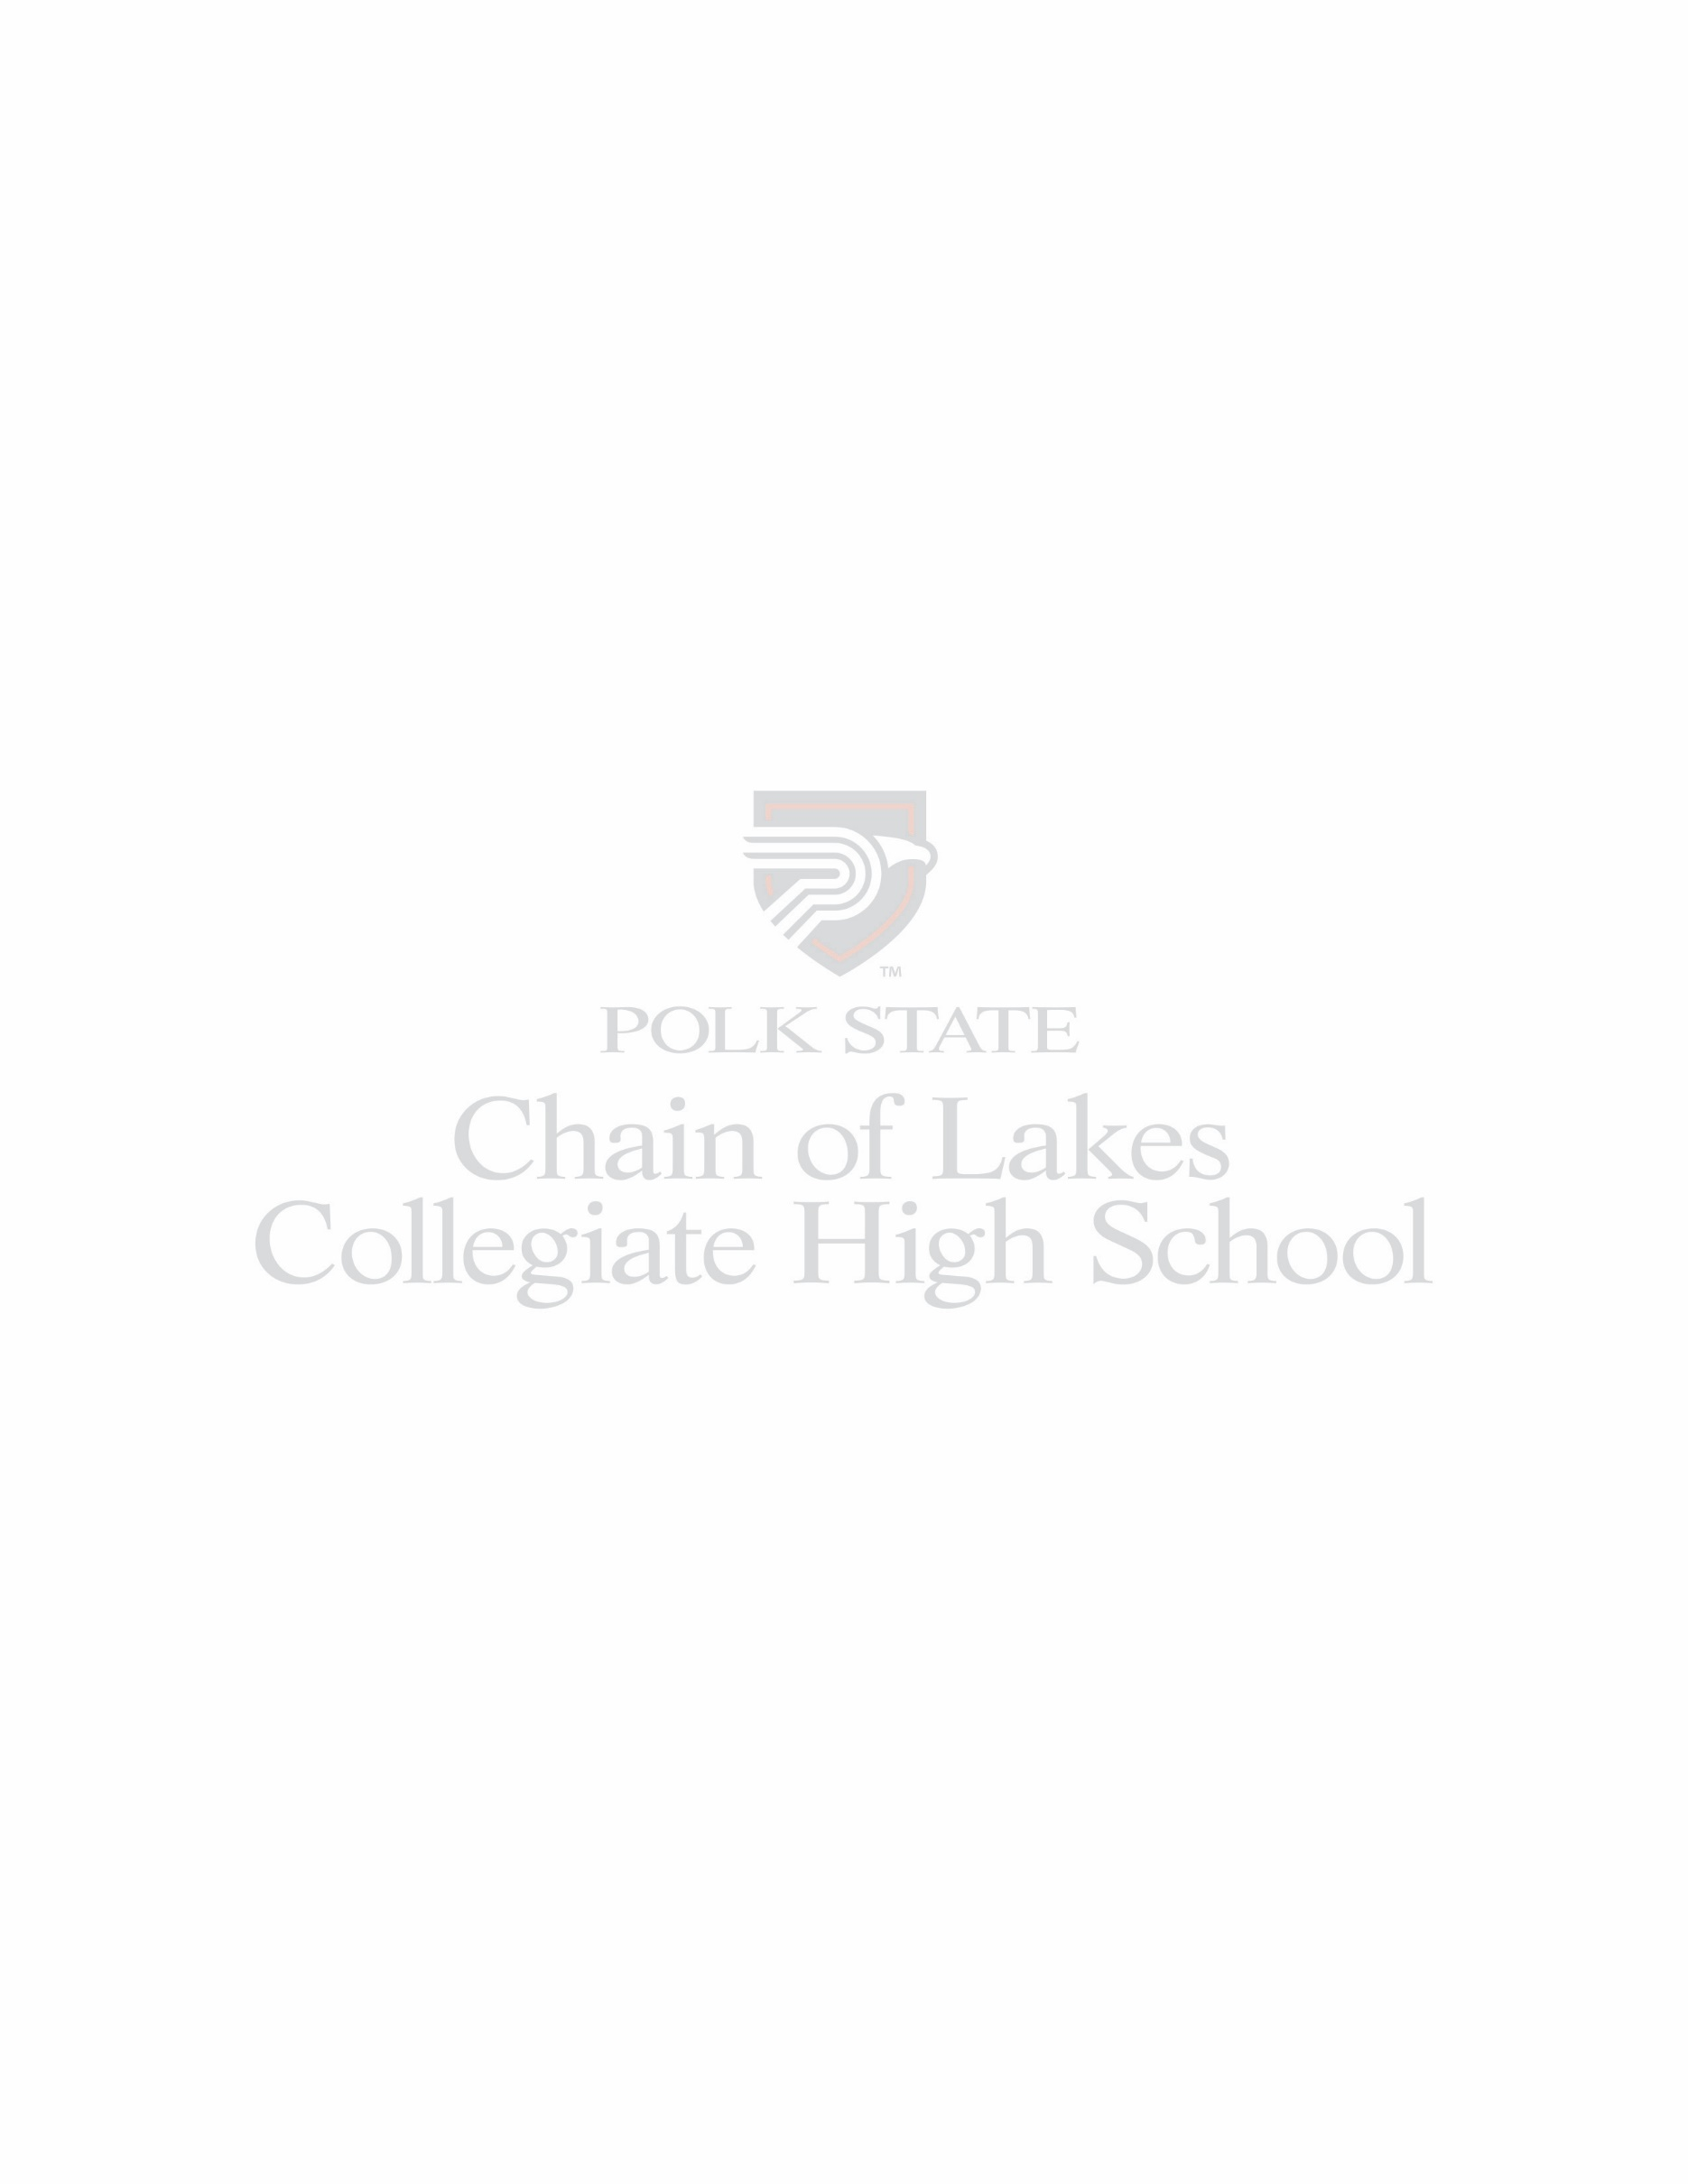

**August 14 – 18, 2023**

**BELL SCHEDULE**

**1st – 7:15 – 8:45 2nd 8:50 – 10:20 3rd 10:25 – 11:55 4th 12:20 – 1:45**

* **WELCOME to the first COL newsletter of the**

**2023-24 school year!**

* Please remember to make a **donation of at least $50** to the COL High School Fund.

<https://secure.qgiv.com/for/pscfd>

**1.Select donation amount**

**2.Please direct my donation to: (Select one) “Chain of Lakes Collegiate High School Fund”**

**3.Enter Donor information**

**4.Optional note/reference input “Student Dues-Student Name”**

**5. Complete Payment**

* **16-week college classes began today!** Be sure to check your PASSPORT and Canvas accounts for any last-minute updates to your classes.
* If you have not **returned your old or picked up your new textbooks**, please do so right away! This is very important for your success.
* Students, your **ID’s are available for pick up in the CHART lab**. You need to obtain yours and begin wearing it in the COL building immediately. Again, ID’s are required in the COL building!
* All students who wish to apply for **free/reduced lunch, applications are due by this Friday, 8/18/24.** After that date, we will only accept applications by request of the parent in the event of a change of income or situation.
* If you need to submit a **change of address**, parents must bring 2 proofs of the new address in person to the office to see Ms. Malpartida.
* Students, please **check Canvas for announcements and information daily!** We will no longer use Remind for students.
* **COL has a Facebook page**! Be sure to like and follow “Polk State Chain of Lakes Collegiate High School.”
* COL does not have a **dress code**, but please use your **tasteful and appropriate judgment**. Administration will advise students of any concerns.

**“This is a new year. A new beginning. And things will change.” – Taylor Swift**